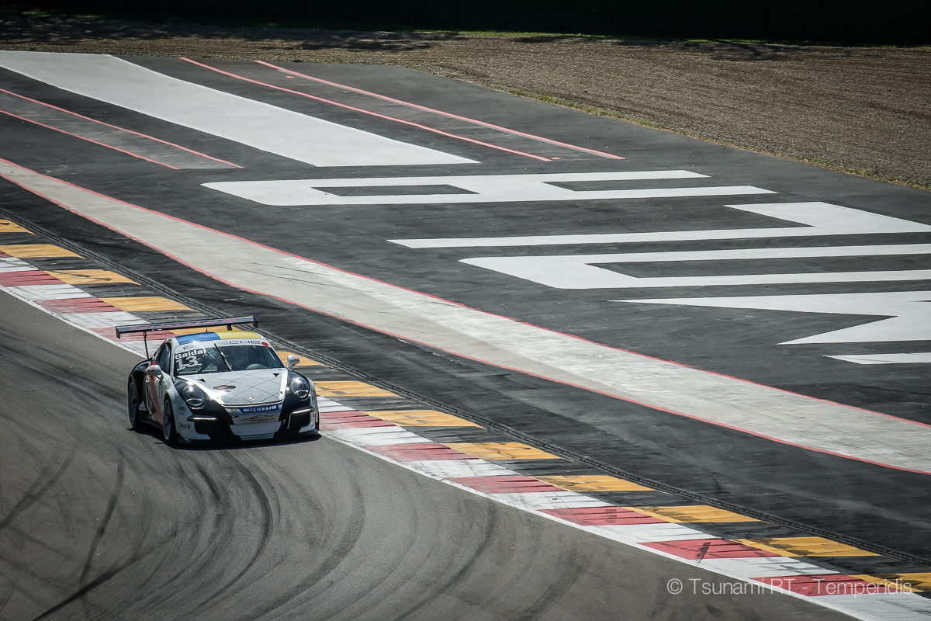
CENTRO PORSCHE PADOVA

Press Release #05.2016 19/4/2016

Pre-season tests in Imola & Monza

Team fully prepared for season premiere in Barcelona
The Ukrainian team completed the official shakedown of Carrera Cup Italia 2016 and exploited an extra test day in Monza during the last weekend.
Tsunami RT - Centro Porsche Padova completed its pre-season testing program last weekend with two very busy days in Imola and Monza.
In the official Imola shakedown organised by Porsche Italia the Ukrainian team tested with three cars and four drivers plus one guest driver. The three Tsunami 991 were driven by Alex Gaidai and young French Alex Jouannem, the duo that will drive for the team in the French Carrera Cup and by Mikael Grenier and Matteo Torta who will share the same 991 in the Carrera Cup Italia.
Since the French star Côme Ledogar didn’t join the team, there was a testing seat available for Egidio Perfetti.
The Imola shakedown proved to be a tricky one because of Matteo Torta’s accident right after the Tamburello corner. The 24 year old Italian lost control of the car and crashed to the concrete barrier damaging the rear of the car. The incident obliged the organisers to red flag the session earlier than the scheduled lunch break. The program continued normally in the afternoon and the repairs on the white Porsche are under way in the San Marino HQ of Tsunami RT - Centro Porsche Padova.
The talented Canadian Mikael Grenier was the fastest Tsunami driver in the day and 4th fastest overall lapping at 1’46”326. Alex Gaidai was 8th fastest with 1’46”945 and French Alex Jouannem 10th overall with 1’47”261. The three Tsunami RT drivers were faster in the day than ex F1 star Robert Kubica, who was the guest star in Imola, working as coach for another PCCI team. Unlucky Matteo Torta was only 18th fastest (1’48”852) among 20 drivers as he couldn’t complete the test.
In the end of the day the Tsunami RT - Centro Porsche Padova team moved to Monza for a supplemental day of testing, thanks to the permission given by Porsche Italia to all the PCCI teams to test in the historic temple of speed. Note that according to PCCI sporting regulation teams can test in the same circuit at least prior 21 days to the race event.
In the next three weeks, the schedule is hectic for the Tsunami RT - Centro Porsche Padova: this week the team travels to Barcelona for the first round of the Carrera Cup France (22-24 April). The week after (29/4 - 1/5) is the first round of the Italian PCC and a week later (5-7 May) is scheduled the special Spa - Francorchamps race, which is valid for the PCCF - a support event to the FIA WEC 6 Hours of Spa event.

Driver quotes:
Alex Gaidai (after Imola): “As I had said before, Imola test was much more revealing than the one at Misano. Now the speed of all rivals is more or less clear. In total the result was good for me today taking into account some nuances. I broke down the left damper and I think the right one was damaged too. I didn’t drive much today as we were focused on our client drivers. Considering everything I am quite satisfied with today’s test”.
Mikael Grenier: “It was great to get back in the car since it was our first test after Misano. It was also great to be driving on the legendary Imola track for the first time! We managed to improve the car during the day, which is important. All in all a solid day with much learned and still improvement to do. Monza was also particular as it was my first time there. A very special track with a much different layout than we are used to. It’s a simple track to learn but difficult to put everything perfectly all in one lap with these massive curbs. The feeling is great so far but we still need to improve in some areas. Tsunami is doing a fantastic job so far, I am very happy to go to Monza to start the season and see where we are against the competition”.
Matteo Torta: “Its a pity [the accident] for me and for the team as well: I couldn’t complete a good testing day and I gave extra job to the team. But I am excited for the upcoming Monza race. I want to show what I couldn’t demonstrate during the test and I will hopefully be a positive surprise”.

Copyright free images
https://www.dropbox.com/sh/fq0441olwqd0t0n/AAAKD9G6J1z0jK7Y6Qyt1YmVa?dl=0
Official Tsunami RT - Centro Porsche Padova website:
http://tsunami-rt.com/en/
Media requests:
media@tsunami-rt.com

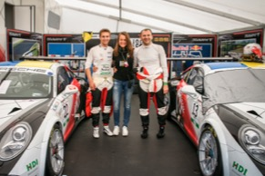
Download link: https://www.dropbox.com/s/f559rwulkxwvehw/DSC01211.jpg?dl=0

