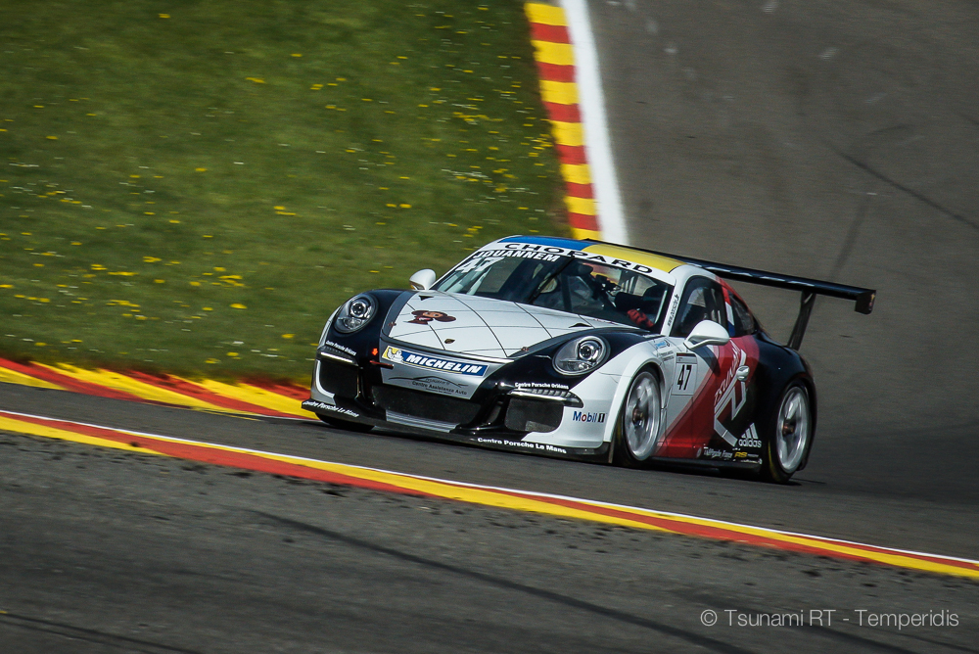

CENTRO PORSCHE PADOVA

Press Release #09.2016 9 May 2016

Porsche Carrera Cup France, Round 2, Spa 5 - 7 May

Bad luck hits Tsunami at Spa Francorchamps
With Alex Jouannem crashing out in the last lap of the first race and Alex Gaidai struggling to get to the podium in the gentlemen class, the Belgian weekend proved a tricky test for the Ukrainian team.

Qualifying
Both Tsunami RT - Centro Porsche Padova drivers had serious problems with traffic in qualifying. Alex Jouannem qualified in 5th place for both races having lapped 2'25"060 in Q1 and 2'24"561 in Q2. Alex Gaidai was P11 in Q1 (2'26"661) and only P16 in Q2 (2'26"547). On both sessions fastest was Matteo Cairoli. The Italian’s best lap was 2'23"195 in Q1.
#47 Alex Jouannem: "I like Spa a lot because its a track where you don't need just technique but 'balls' as well. My qualifying was not good - I am impressed I am P5 in these conditions. I almost had a crash trying to avoid some slower cars".
#13 O.Gaidai: "In Q1 I drove very well, although there was traffic in my fastest lap and I’ve lost precious time in it. The problem comes from some very slow drivers on track. But I enjoyed the car and tried to drive fast. Q2 was unsuccessful, it was much more difficult to drive, the car’s behaviour was not very clear”.

Race 1
Alex Jouannem did a strong, combative race fighting for a podium finish till the very last lap, where - while he was 4th - the French did a small mistake on the fast Paul Frère corner, touched the dirty and rolled out of the track. Alex was OK but the car was not fit for the second race, so the Spa round finished disappointingly for the talented French driver and Tsunami.
Alex Gaidai had an adventurous race that started with an unavoidable crash on the first La Source corner and finished in 12th position, 4th among category B drivers and 3rd among the PCCF gentlemen. Matteo Cairoli dominated the race from the start to the finish flag.
#47 Alex Jouannem: “I am disappointed… I made a mistake and damaged the team’s car, I spoiled a good race and the entire race week end. This is a shame because we had excellent pace and were in a position to score very strong points. Unfortunately, these things happen and you must learn from them. For sure, what happened isn't ideal, but the championship is still long. It isn't in my nature to give up after a set back, if anything, it will fuel my motivation to be even stronger for the rest of the year. I will continue pushing to be at the front....”
#13 O.Gaidai: ”Right from the start I overtook Latorre, and in front of me was Julien Andlauer. In a corner he blocked the wheels, drove straight and then tried to get into this corner turning at a right angle. Since everyone else was inside the corner, he crossed the lines of other drivers. As a result I hit him in the door. He spun, and I lost one or two positions. Then, in Eau Rouge, someone hit me too because my car had lost much speed. The front bumper was broken, and the car lacked downforce and, thus, speed, so the whole race was very hard for me. But I drove, I fought”!
Race 1 Classification
1. Matteo Cairoli 12 laps in 30’58”522, 2. Jaap Van Lagen +6.067”, 3. Mathieu Jaminet +11.179”, 4. Joffrey de Narda +22.016”, 5. Vincent Beltoise +23.532”, 6. Dylan Derdaele +26.363” …. 9. Christoph Lapierre (1st cat. B) +34.456” … 12. Alex Gaidai +43.698”

Race 2
In the second 30’ race of Porsche Carrera Cup France in Spa, three hours before the start of the prestigious WEC 6 hours event, Alex Gaidai was left alone to defend the Tsunami RT - Centro Porsche Padova colours. The Tsunami driver was fighting for the category B podium against Christophe Lapierre. When the French veteran closed his line in a corner, Gaidai had to brake hard and spun. The Ukrainian’s race practically finished there, as he practically was left in the back of the field. Later in the race, Lapierre had an exit in Eau Rouge and his accident called the safety car in the track. The race finished behind SC with Gaidai 25th. Matteo Cairoli took a deserved second win in front of Mathieu Jaminet.
#13 O.Gaidai: “For sure I am upset. The fight was interesting and I did my best. But overall, the weekend was rather mediocre for the team. To be honest, today’s result doesn’t reflect my driving level. We must take the lesson from this race and keep moving forward”.
Race 2 Classification
1. Matteo Cairoli 12 laps in 32’52”679, 2. Mathieu Jaminet, 3. Joffrey de Narda, 4. julien Andlauer, 5. Jap Van Lagen, 6. Vincent Beltoise … 8. Roar Lindland (1st cat. B) … 25. Alex Gaidai

Images by Tsunami from Spa:
https://www.dropbox.com/sh/1r66kgnede2roqt/AAD1-17YhWhKyI11S8kfQmm3a?dl=0
Officlal Tsunami RT - CPP website:
http://tsunami-rt.com/en/
Media requests:
media@tsunami-rt.com
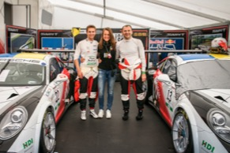
Download link: https://www.dropbox.com/s/f559rwulkxwvehw/DSC01211.jpg?dl=0

